**Part 1. (6 points) Match the Scenario to the Test.** There is one of each of the following tests described in the scenarios: **one sample z test for the population mean, one sample t test for the population mean, and a one sample z test for the population proportion.** For each scenario decide what type of hypothesis testing procedure is appropriate and **explain why**.

**Scenario 1.** A manufacturer of seat belts routinely samples the strength of seat belts to ensure their product meets specifications. Past experience has indicated the breaking strength of seat belts is normally distributed with a standard deviation of $σ=4 psi$. A random sample of 16 specimens yields an average breaking strength of 2003 psi. What type of procedure is appropriate to test whether the mean is other than the desired 2000 psi?

Here, the sample size is small (16), but the standard deviation is known. Due to the small sample size, a one sample t test for the population mean should be appropriate as the t-distribution provides a better approximation of the sample mean's distribution given the circumstances.

**Scenario 2.** In an effort to support students beyond tuition assistance, a philanthropy group would like to provide eligible students with a monthly amount for food and groceries. They would like to know if $300 a month is a reasonable amount to support a student. A report from a University’s housing and dining department claims students spend on average $315 on food and groceries per month with a standard deviation $126. They assume this data from a random sample of 161 students represents the population. Which procedure is appropriate to investigate whether $300 is not a reasonable amount per month, on average?

In this situation, we are given a mean (315), SD (126) and a large sample size (161). The question is about the average amount, and the population variance is known. This makes it appropriate to use a one sample z-test for the population mean to test if $300 is reasonable.

**Scenario 3.** During a viral pandemic, a state applies a tiered risk assessment to counties based on the proportion of residents who test positive for the virus. Suppose a county randomly samples and tests 1000 residents for the virus every two weeks. If the proportion of positive tests is more than 0.01, the county is assessed as high risk. Which procedure is most appropriate to test whether the proportion for positive tests is more than 1%?

With a sample size of 1000, the focus is on whether the proportion exceeds 1%. This clearly indicates the use of a one sample z-test for the population proportion, since the interest is a proportion and the sample size is large for a normal approximation to be valid.

**Part 2. (9 points)** Suppose a new initiative is interested in increasing the percent of students who identify as female to pursue an engineering or computer science degree. A university will receive funding to actively market to these students if there is evidence that less than 1 in 3 engineering or computer science students identify as female. Use the information presented in the bar graph below to answer the following questions.

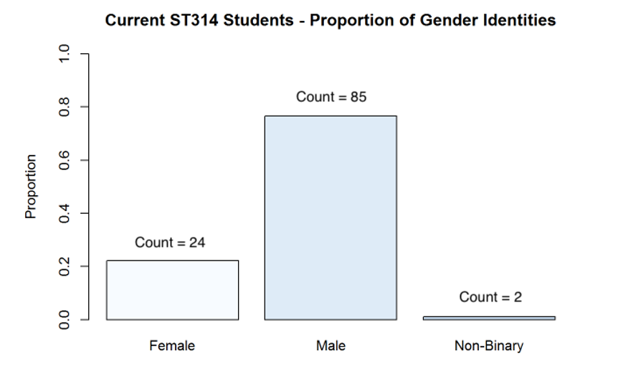

**Is there evidence the proportion of all OSU engineering students who identify as female is less than 0.33?**

Use a significance level of 0.01.

1. (0.5 points) Based on the bar chart of the data is there evidence the proportion of those who identify as female is less than 0.33? How many students are in the sample?   
   Out of 111 students, 24 are female. That is around 0.216 which is less that 0.33.
2. (1 point) State the null and alternative hypotheses.

Null: p = 0.33 (proportion of female students Is 0.33)

Alternative: p < 0.33 (proportion of female students is less than 0.33)

1. (0.5 points) Do you think it is appropriate to use the ST314 Student Survey data to represent the population of all OSU engineering students? Why or why not?

I don’t think using the ST314 survey is representative of the population of all OSU engineering students. There are many students that were not taking the class at the time and do not need to take that class but are engineering students.

1. (1 point) Check conditions. Are they met? *If not, still proceed.*

We need a large enough sample size where np >= 10. N being sample size and P being the estimate proportion. 111 * 0.33 is around 37, meeting the condition.

1. (1 point) Calculate the test statistic. Show work!
$$z=\frac{0.216-0.333}{\sqrt{\frac{0.333*0.667}{111}}}$$

$$z=\frac{-0.117}{\sqrt{0.00201}}$$

$$≈ -2.61$$

2. (0.5 point) Give the appropriate p-value and state whether it is one-sided or two-sided.

Given the test score of -2.61 in a left tailed test, we can calculate the p-value to be 0.0045, which Is less that the significance value of 0.01. This is a one-sided test since the alternative hypothesis is p < 0.33.

1. (1.5 point) Calculate the appropriate 99% confidence interval. Show work!
$$CI=0.216±2.576\sqrt{\frac{0.216(1-0.216)}{11}}$$

$$CI=0.216±0.0989$$

$$(0.1171, 0.3149)$$

2. (3 points) Finally, using the results from parts e, f and g, summarize your conclusions to the university. Construct a four-part conclusion, which includes a statement in terms of the alternative, whether you reject or fail to reject the null based on a significance level, state and interpret the confidence interval and point estimate and include context.

The sample provides a point estimate of 0.216 for the proportion of female students in the engineering program. The 99% confidence interval ranges from 0.1171 to 0.3149, which represents the true proportion. We reject the null hypothesis that the proportion of female engineering students is 0.333 because the p-value of approximately 0.0045 is less than the significance level of 0.01. It can be concluded that the proportion of female engineering students at OSU is significantly lower than 0.33 with 99% confidence; the university should consider this as evidence of underrepresentation of females in the engineering program.

**Part 3. (8 points)** The microbeers_Winter2024.csv dataset is a random sample of **75** microbrews from around the United States. The variable “abv” represents the percent of alcohol by volume for each craft beer. According to the National Institute of Health, one standard serving of alcohol is usually about **5%** alcohol by volume (abv).

**Does the sample of microbrews provide evidence the average alcohol by volume of all craft beers is different from a standard serving of beer at 5% abv?**

Use this dataset and the R script **DA5_t_procedures.R** to complete the following:

1. (0.5 point) What is the parameter of interest in this scenario? Provide the symbol and context.

The parameter of interest in this case is the true average Alcohol by Volume.

1. (1 point) State the null and alternative hypothesis to answer the question of interest.

Null: µ = 5 (the mean abv is %5)

Alternative: µ ≠ 5 (the mean abv is not %5)

1. (1.5 points) Make a histogram or boxplot to visualize the variable abv. Is there visual evidence the average alcohol by volume is different than 5%?

There is visual evidence that the average is very close to 5.

1. (1 point) Check the conditions for inference. State them and whether they are met.

Randomly samples: Met

Normal distribution or large enough sample size: some skewness but large sample size, met

Independence of data: met

1. (1 point) Use the **t.test()** command in R to perform the test. Paste your results.

data: microbeers$abv

t = 4.4017, df = 74, p-value = 3.555e-05

alternative hypothesis: true mean is not equal to 5

95 percent confidence interval:

5.407206 6.080794

sample estimates:

mean of x

5.744

1. (3 points) From the R output, write a four-part conclusion describing the results. Use $α = 0.05$. Provide a statement in terms of the alternative hypothesis. State whether (or not) to reject the null. Give in context an interpretation of the point and interval estimate. Include any other information you might feel to relevant.

The sample mean ABV is 5.744%. The 95% confidence interval for the true mean ABV is from approximately 5.407% to 6.081%.The null hypothesis is rejected that the mean ABV is %5. Taking this in, we can conclude that there is statistical evidence to suggest the average ABV differs from %5.

**Gradescope Page Matching (2 points)**

When you upload your PDF file to Gradescope, you will need to match each question on this assignment to the correct pages. Video instructions for doing this are available in the Start Here module on Canvas on the page “Submitting Assignments in Gradescope”. Failure to follow these instructions will result in a 2-point deduction on your assignment grade. Match this page to outline item “Gradescope Page Matching”.